**COMP 1231: Assignment 3 Testing Exhibit**

Anton Nikitenko (T00622037)

Part 1 (Average.java)

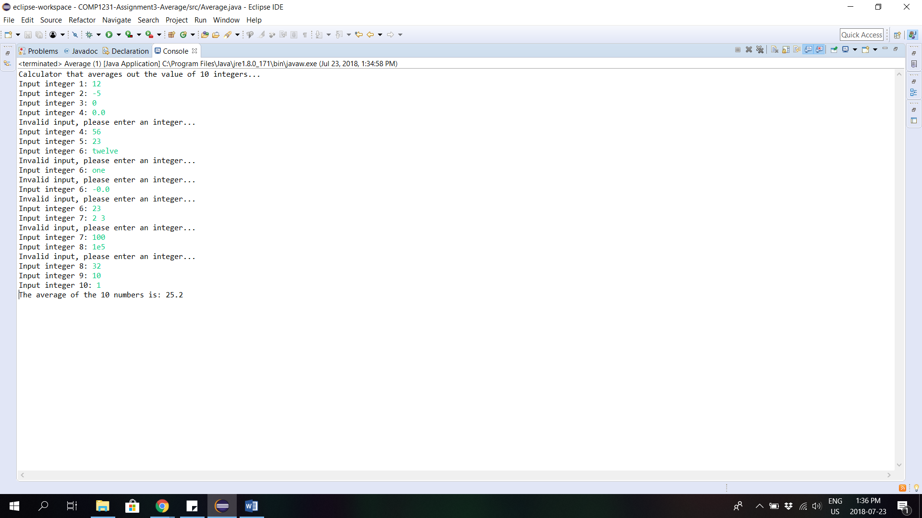

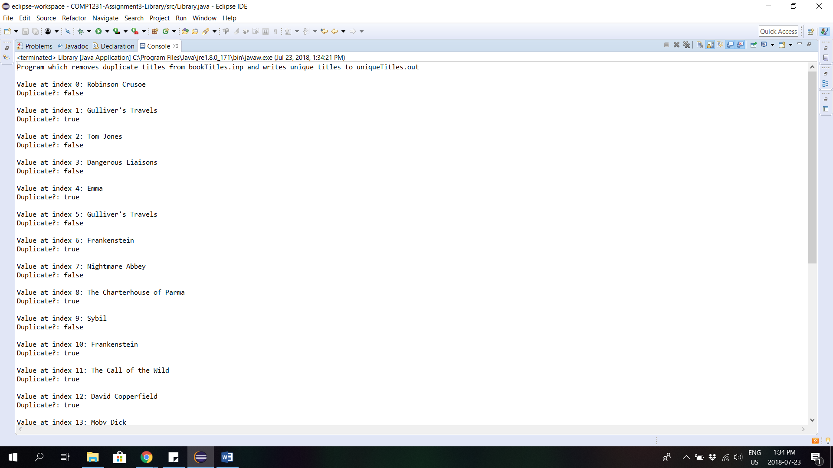Part 2 (Library.java)

